**BCS 345 Lab – JavaFX - ListView**

***Overview***

Write a JavaFX application that uses a ListView. The ListView will display TV show names.

***Part 1***

Create a window according to the following specifications:

1. Create a new project.
2. Add a Driver class and create a main method inside of it.
3. Create an Application class with an override of start.
4. Create a controller class. Event handlers should be defined in this class (do not need them yet).
5. Create an FXML file for the GUI.
   1. Make the root an AnchorPane
   2. Add a VBox as a child of the AnchorPane
   3. Add a ListView as a child of the AnchorPane
   4. Populate the ListView with some initial data using FXML.
   5. Make the title of the window “Lab – JavaFX ListView”.

Hint: You can do this in code in the start method of the Application class. Just set the title on the primary stage before you call show on it.

You should see the following:

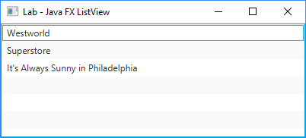

***Part 2***

Update the GUI so that the user can add new shows to the list. You will need to add a Label, a TextField, and a Button to the GUI. When the user presses the Add Show button it should add the show they typed in to the ListView. The TextField should be cleared automatically after adding the new show to the ListView. You can use an HBox to get the Label and TextField to appear next to each other horizontally. Following is a screenshot of what it should look like after adding “Silicon Valley”:

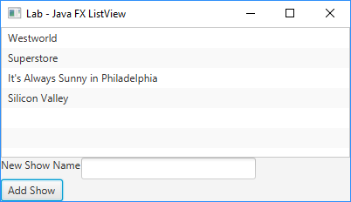

***Part 3***

Update the GUI so that the user can clear the ListView. Add a Clear button below the Add Show button. Following is a screenshot of what it should look like after pressing the Clear button:

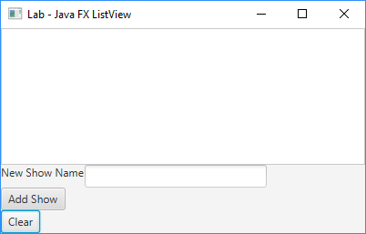

***Part 4***

Add code to handle a ListView item selection. When a ListView item is selected it should print a message in the console window. Here is a screenshot of what you should see in the console window when Superstore is clicked:

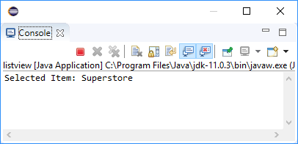

***Part 5***

Update the application so that it can read show names from a file. You will need to do the following:

1. Create a new text file in the project directory. Add show names on separate lines in the file.
2. Add a button to the GUI. Place the button below the Clear button. The button should say “Read From File”.
3. Add an event handler for the Read From File button. This event handler should use a FileChooser to get the selected file from the user. Once you have the selected file you should open it and read the data in. Each piece of data should be added to the ListView. The ListView should only contain data from the file (clear the ListView before adding the file data).

Here is what it should look like after the data is read from a file (when you click the Read From File button you should see an open file dialog first):

